**IT equipment management system of**

**College of Arts, Media and Technology**

Project Plan

By

**Mr. Nathawut Supavananusorn 542115020**

**Mr. Tanadol Parn-ong 542115021**

Department of Software Engineering

College of Arts, Media and Technology

Chiang Mai University

Project Advisor

________________________

**Dr. Prompong Sugunnasil**

**Document History**

|  |  |  |  |  |  |  |
| --- | --- | --- | --- | --- | --- | --- |
| **Document Name** | **Version** | **Status** | **Date** | **Viewable** | **Reviewer** | **Responsible** |
| **Documents** | | | | | | |
| IT equipment management system of College of Arts, Media and Technology –Project plan_v1.0.docx | Create  Chapter One–Introduction  Chapter Two–Infrastructure  Chapter Three–Quality Planning  Chapter Four–Software Standard  Chapter Five–Estimated of Tasks  Chapter Six–Risks  Chapter Seven–Version Control | Realse | 23 June 2015 | NS, TP, PS | NS,TP | NS |

**\*NS = Nathawut Supavananusorn**

**\*TP = Tanadol Parn-ong**

**\*PS = Dr. Prompong Sugunnasil**

Contents

**Chapter One | Introduction** 4

1.1 Project Overview 4

1.2 Acronyms and Definition 5

1.3 Work Product to be developed 7

**Chapter Two | Infrastructure** 8

2.1 Hardware/Software Acquisition Plans 8

***2.2*** Management Procedure 9

2.3 Monitoring and Controlling Mechanisms 10

2.4 Change Management 14

**Chapter Three | Quality Planning** 15

3.1 Quality Factors 15

3.2 Reviews/Responsibility 16

3.3 Testing 16

**Chapter Four | Software Standard** 17

4.1 Project Management (PM) process 17

4.2 Software Implementation (SI) process 18

**Chapter Five | Estimated of Tasks** 20

5.1 Estimated Duration of Tasks 20

5.2 Estimated Effort and Cost 20

**Chapter Six | Risks** 21

**Chapter Seven | Version Control** 22

7.1 Naming Conversion 22

7.2 Project Repository 22

7.3 Configuration Item Table 23

# **Chapter One | Introduction**

IT equipment management system of College of Arts, Media and Technology is a system that helps the administrator to manage the user account, IT equipment and summary report. This system can support the technician to get task automatically, manage the repair information and get new task notification via email. So, the technician can work quickly because the system will calculate the time to repair in each technician before assigning the task for the technician. Also, this system provides the reporter to inform the broken IT equipment via the web application and get new repair information notification via email. Which the reporter does not need write the informed document and submit to the repair department.

## **Project Overview**

The main objectives are a development IT equipment management system of College of Arts, Media and Technology that provides the user manage on the Internet in order to support the user to use this system quickly. This designed system provides the management information system for the administrator. Which the administrator can manage summary report, IT equipment information and the user account. Such the system will provide convenience about the tasks distribution equally, repair management and new task notification via email for the technician. This system also provides the reporter inform the broken IT equipment via the web application and get new repair information via email.

* + 1. **Purpose**

The software project management plan is a document for plan the project, evaluating project. The planning can reduce the cost from project. The project plan is a plan before start project and when project start, project plan is used to tracking and control project follow the plan.

* + 1. **Scope**

The scopes of this project plan and quality plan are:

* For managing the schedule to develop IT equipment management system of College of Arts, Media and Technology.
* For managing the risk those can occur during the development.
* Specify the tools those used for developing the project.
* Specify the developers who have responsible to develop the project.
* Specify the deliverable items in each phase.
* Describe the quality plan of this project.

## **Acronyms and Definition**

**Acronyms**

AC Activity diagram

SDD Software design document

SPMP Software project management plan

SRS Software requirement specification

URS User requirement specification

UC Use case

UI User interface

CSS Cascading style sheets

CD Class diagram

SD Sequence diagram

STC System test case

UTC Unit test case

MDA Method design Attribute

MDM Method design method

**Definition**

**IEEE**

Institute for Electrical and Electronics Engineers. Biggest global interest group for engineers of different branches and computer scientists. [IEEE90]

**Milestone**

A significant event in the project, usually completion of the main deliverable. [IEEE90]

**Plan**

A documented series of tasks requires meeting an objective, typically including the associated schedule, budget, resources, organizational description and work breakdown structure. [IEEE90]

**Project management**

The application of knowledge, skills, tools, and techniques to project activities in order to meet or exceed stakeholder needs and expectations from a project. [IEEE90]

**Project Plan**

A formal, approved document used to guide both project execution and project control. The primary uses of the project plan are to document planning assumptions and the decision, to facilitate communication among stakeholders, and to document approved scope, cost, and schedule baseline. [IEEE90]

**Risk**

An uncertain event or condition that, if it occurs, has a positive or negative effect on the project’s objectives. It is a function of the probability of occurrence of a given threat’s occurrence. [IEEE90]

**Risk management**

The systematic application of management policies, procedures and practices to the tasks of identifying, analyzing, evaluating, treating and monitoring risk. [IEEE90]

**System testing**

Testing conducted on a complete and integrated system for evaluate the system’s compliance with its specified requirements [IEEE90]

**Traceability**

The ability to trace the history, application or location of an item or activity, or work products or activities, by means of recorded identification. The establishment and maintenance of relationships between such items. Horizontal traceability describes the relationship between work products of the same type (e.g., Customer requirements). Vertical traceability describes the relationship between work products, which build or derived from each other (e.g. from customer requirements to qualification test cases). Bidirectional traceability allows to directly following relationships in both directions. [IEEE90]

**Validation**

Confirmation by examination and provision of objective evidence that the particular requirements for a specific intended use are fulfilled (“doing the right thing”). [IEEE90]

**Verification**

Confirmation at the end of the process by examination and provision of objective evidence that specified requirements to the process have been fulfilled (“doing things right”). [IEEE90]

**UML Unified Modeling Languages**

Standardized notation for modeling design descriptions, architectures or scenarios. Not depending on a specific method. Issued and maintained by the object Management Group (OMG). [IEEE90]

**Unit test**

A test of individual programs or modules in order to remove a design or programming errors. [IEEE90]

## **Work Product to be developed**

* + 1. **Deliverables**

|  |  |  |  |  |
| --- | --- | --- | --- | --- |
| **No.** | **Deliverables/Release** | **Media** | **No. of**  **Copies** | **Data** |
| 1. | **The Proposal report**  Project Proposal version 2.0 | Hard copy | 1 | 09/06/2015 |
| 2. | **The Final progress report**   * Project Management Plan version 2.0 * Software Requirement Specification version 2.0 * Software Design Document version 2.0 * Test Plan version 2.0 * Test record version 2.0 * Traceability record version 2.0 | Hard copy | 3 | 30/06/2015 |

# **Chapter Two | Infrastructure**

## **Hardware/Software Acquisition Plans**

* + 1. **Testing tools**
* **Hardware**
* Mac pro retina 2013 with Window 7 Ultimate
* Dell Inspiron 5423 with Window 8.1 pro
* **Software**
* Google Chrome 43.0.2357.130 m
  + 1. **Development tools**
* Microsoft SQL Server
* Microsoft Visual Studio
* Mandrill
* Window Azure
* Internet Information Service (IIS)
* Bootstrap
  + 1. **Configuration management tools**
* GitHub
  + 1. **Document tools**
* Microsoft Word 2013
* Visual Paradigm
* GanttProject

## **Management Procedure**

* + 1. **Project Team Structure**

|  |  |  |  |
| --- | --- | --- | --- |
| No. | Participants | Roles | Responsibility |
| 1. | Mr.Nathawut Supavananusorn | System Analysis, Designer, Programmer, Tester | - Project Proposal  - Software Requirement Specification  - Software Design Document  - Software coding  - Test Plan document  - Test Record document  - Traceability record document |
| 2. | Mr.Tanadol Parn-ong | System Analysis, Designer, Programmer, Tester | - Project Proposal  - Project Management Plan  - Software Requirement Specification  - Software Design Document  - Software coding  - Test Plan document  - Test Record document  - Traceability record document |

## **Monitoring and Controlling Mechanisms**

* + 1. **Software Development Model**

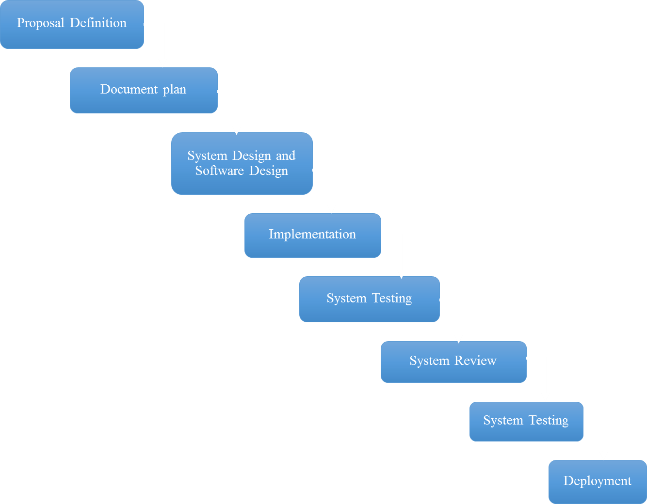

In a waterfall model, each phase must be completed fully before begin the next phase. At the end of each phase, a review takes place to determine if the project is on the right path and whether or not to continue or discard the project. In this model, the testing starts after the development is complete only. The waterfall model phases do not overlap.

**Proposal phase:** This phase is about creating a proposal for IT equipment management system of College of Arts, Media and Technology.

**Document plan phase:** This phase is about document for planning and designs the overall system from requirement given by the user. Iterative all features: This phase is about separate system into many features and then iterative create all feature from the first feature till the final feature. For this phase, it will be divided into 4 phases. There are;

**- Plan:** Planning the method for creating and test each feature.

**- Implement:** Implementing and coding each feature.

**- Test:** Testing and fixing each feature.

**- Review:** Reviewing and maintaining each feature to meet the feature plan.

**System test phase:** This phase will integrate all features into one system and then create test document from system testing.

**Deploy phase:** This phase is about deploying the whole system to server and use as a regular mobile application.

* + 1. **Status Reporting**

|  |  |  |  |
| --- | --- | --- | --- |
| **No.** | **Progress Report** | **Software items** | **Date** |
| 1. | Final Progress | * Project Management Plan version 0.1 * Software Requirement Specification version 0.1 (Feature 1,2,3,4,5,6,7) * Software Design Document version 0.1(Feature 1,2,3,4,5,6,7) * Test Plan version 0.1 (Feature 1,2,3,4,5,6,7) * Test Record version 0.1 (Feature 1,2,3,4,5,6,7) * Traceability record version 0.1 | 23/06/2015 |

**Features**

**Feature#1** Account management

**Description:** This feature provides the Administrator to create account and define Technician and Reporter active status in this system.

**User:** Administrator.

**Details:**

**1-1 Administrator:** User can create technician/reporter accounts.

**1-2 Administrator:** User can define active status of technician/reporter accounts.

**Feature#2** Login/Logout System

**Description:** This feature provides the user to sign-in by username and password for use this system.

**User:** Administrator, Technician, Reporter

**Details:**

**2-1 Administrator/Technician/Reporter:** User can log in to the system.

**2-2 Administrator/Technician/Reporter:** Usercan log outfrom the system.

**Feature#3** Add/Update IT equipment

**Description:** This feature provides the Administrator to manage IT equipment.

**User:** Administrator

**Details:**

**3-1 Administrator:** User can add IT equipment to the system.

**3-2 Administrator:** User can update IT equipment information in the system.

**Feature#4** Management Information system

**Description:** This function provides the Administrator to get repairing summary per month or per year, to report repairing summary of each person per month or per year, and to report almost expire of IT equipment to the administrator.

**User:** Administrator

**Details:**

**4-1 Administrator:** User can view report almost expire of IT equipment in the system.

**4-2 Administrator:** User can view IT equipment that are often broken

**Feature#5** Repair informing system

**Description:** This feature provides the Reporter to inform about broken IT equipment for the Technician.

**User:** Reporter

**Details:**

**5-1 Reporter:** User can inform broken IT equipment to the system.

**5-2 Reporter:** User views history of his repairing informs in the system.

**Feature#6** Repair management system

**Description:** This feature provides the Administrator to define repairing’s jobs type, which get from informing of reporter. Moreover, this feature provides the Technician to update or view his jobs.

**User:** Technician, Administrator

**Details:**

**6-1 Technician:** User can view his repairing job detail in the system.

**6-2 Technician:** User can update his repairing job detail in the system.

**6-3 Technician:** User can view history his repairing jobs in the system.

**6-4 Administrator:** User can define repairing’s job type in the system.

**6-5 Technician:** User can get tasks automatically by calculating from time to repair in each technician.

**6-4 Administrator:** User can request to distribute repair tasks again to the system.

**Feature#7** Notification system

**Description:** This feature provides the Technician/ the Reporter to receive repairing detail via them email.

**User:** Technician, Reporter

**Details:**

**7-1 Technician:** User can receive an email about repairing inform detail.

**7-2 Reporter:** User can receive an email about updating status of repairing when technician update their status.

**7-3 Administrator**: User can receive an email when reporter inform broken detail

## **Change Management**

Change control procedure

1. Admit the change.
2. Analyze the reason for the change.
3. Send change form to project advisor.
   1. If accept: make a change in project from change request form.
   2. If reject: Continue in the project and find the way to solve a problem.
4. Analyze the result from changing and modify the document or system to match with change.

# **Chapter Three | Quality Planning**

**Quality Planning [V&V]**

## **Quality Factors**

According to McCall’s factor model, IT equipment management system of College of Arts, Media and Technology should meet these quality factor after complete;

* + 1. **Product operating factors**
* **Correctness**
* The software product should able to provide 100% correctness of data from user request.
* The information in the system should be up to date at all time.
* **Reliability**
* The system should have a failure rate lower than 10% after deployed.
* **Integrity**
* The system should able to identify the authentication of every user.
* The system should able to limit some features and pages from unauthorized user.
  + 1. **Product revision factors**
* **Maintainability**
* The software should have at least 20% of comment comparing with the whole Line of code to support the future maintenance activity.
* The software should return measurable output for future maintenance activity.
* **Testability**
* The software should able to be tested 100% of all feature and flow of processes.
  + 1. **Product transition factors**
* **Portability**
* The system should able to supportGoogle Chrome internet browser.
* **Reusability**
* More than 20% part of finished software product should able to be reused in future development.

## **Reviews/Responsibility**

|  |  |  |  |  |
| --- | --- | --- | --- | --- |
| **Stage Exit Review** | | | | |
| **No.** | **Stage** | **Review Item** | **Responsibility** | **Reviewer** |
| 1. | Proposal | Project proposal version 2.0 | NS,TP | NS,TP,PS |
| 2. | Final progress | Software Requirement Specification version 2.0 | NS,TP | NS,TP,PS |
| 3. | Final progress | Software Design Document version 2.0 | NS,TP | NS,TP,PS |
| 4. | Final progress | Test Plan version 2.0 | NS,TP | NS,TP,PS |
| 5. | Final progress | Test Record version 2.0 | NS,TP | NS,TP,PS |
| 6. | Final progress | Traceability record version 2.0 | NS,TP | NS,TP,PS |

## **Testing**

|  |  |  |
| --- | --- | --- |
| **Testing Process** | | |
| **No.** | **Test** | **Responsibility** |
| 1. | Unit Testing | NS,TP |
| 2. | System Testing | NS,TP |

# **Chapter Four | Software Standard**

**Software Development Standard**

**ISO29110 for Very Small Entity (VSE)**

ISO 29110 is a guide applies to Very Small Entities (VSEs), enterprise, organization, department or project up to 25 people, dedicated to software development. The Guide provides Project Management and Software Implementation process which integrate practices based on the selection of ISO/IEC12207- Systems and Software Engineering –Software Life Cycle process - guidelines for the content of software life cycle process information products (documentation) standards elements.

## **4.1 Project Management (PM) process**

**PM purpose**

The purpose of the Project Management process is to establish and carry out in a systematic way the tasks of the software implementation project, which allows complying with the project’s objectives in the expected quality, time and costs.

**PM objectives**

**PM.O1:** The Project Plan for the execution of the project is developed according to the Statement of Work and validated with the Customer. The tasks and resources necessary to complete the work are sized and estimated.

**PM.O2:** Progress of the project is monitored against the Project Plan and recorded in the Progress Status Record. Corrections to remediate problems and deviations from the plan are taken when project targets are not achieved. . Appropriate treatment is taken to correct or avoid the impact of risk. Closure of the project is performed to get the Customer acceptance documented in the Acceptance Record

**PM.O3:** The *Change Requests* are addressed through their reception and analysis. Changes to software requirements are evaluated for cost, schedule and technical impact.

**PM.O4:** Review meetings with the Work Team and the Customer are held. Agreements are registered and tracked.

**PM.O5:** Risks are identified as they develop and during the conduct of the project.

**PM.O6:** A software Version Control Strategy is developed. Items of Software Configuration are identified, defined and base lined. Modifications and releases of the items are controlled and made available to the Customer and Work Team including the storage, handling and delivery of the items.

**PM.O7:** Software Quality Assurance is performed to provide assurance that work products and processes comply with the Project Plan and Requirements Specification.

**PM Activities**

The Project Management Process has the following activities:

- PM.1 Project Planning

- PM.2 Project Plan Execution

- PM.3 Project Assessment and Control

- PM.4 Project Closure

## **4.2 Software Implementation (SI) process**

**SI purpose**

The purpose of the Software Implementation process is the systematic performance of the analysis, design, construction, integration and tests activities for new or modified software products according to the specified requirements.

**SI objectives**

**SI.O1:** Tasks of the activities are performed through the accomplishment of the current Project Plan.

**SI.O2:** Software requirements are defined, analyzed for correctness and testability, approved by the Customer, base lined and communicated.

**SI.O3:** Software architectural and detailed design is developed and base lined. It describes the software items and internal and external interfaces of them. Consistency and traceability to software requirements are established.

**SI.O4:** Software components defined by the design are produced. Unit test are defined and performed to verify the consistency with requirements and the design. Traceability to the requirements and design are established.

**SI.O5:** Software is produced performing integration of software components and verified using Test Cases and Test Procedures. Results are recorded at the Test Report. Defects are corrected and consistency and traceability to Software Design are established.

**SI.O6:** A Software Configuration, that meets the Requirements Specification as agreed to with the Customer, which includes user, operation and maintenance documentations is integrated, base lined and stored at the Project Repository. Needs for changes to the Software Configuration are detected and related Change Requests are initiated.

**SI.O7:** Verification and Validation tasks of all required work products are performed using the defined criteria to achieve consistency among output and input products in each activity. Defects are identified, and corrected; records are stored in the Verification/Validation Results.

**SI activities**

The Software Implementation Process has the following activities:

- SI.1 Software Implementation Initiation

- SI.2 Software Requirements Analysis

- SI.3 Software Architectural and Detailed Design

- SI.4 Software Construction

- SI.5 Software Integration and Tests

- SI.6 Product Delivery

# **Chapter Five | Estimated of Tasks**

## **5.1 Estimated Duration of Tasks**

|  |  |  |
| --- | --- | --- |
| **Task and Estimated Duration** | | |
| **No.** | **Phase** | **Estimated Duration (Days)** |
| 1. | Proposal | 9 |
| 2. | Final progress | 13 |
|  | Total | 22 |

## **5.2 Estimated Effort and Cost**

IT equipment management system of College of Arts, Media and Technology is supported by College of Arts, Media and Technology, Chiang Mai University as a senior project. This project is limited supporting. The faculty will provide 500 Baht for poster presentation, and will provide hardware for development base on request and other justification.

# **Chapter Six | Risks**

**Identification of Project Risks**

|  |  |
| --- | --- |
| **Risk** | **Solution** |
| **Human Risks** | |
| Group members are lack in skill and knowledge. | - Lean from a textbook and websites.  - Asking about solutions in group member together. |
| One of group members has a lot of duty to do | - Separation of works should have equal works in each group members |
| There is bad communication in group members. | - Try to more communicate in group members |
| **Process Risks** | |
| Scope of the project should be changed. | - Team project advises with project’s advisor for suggestion.  - Create a change request document and then sent to project’s advisor. |
| Project’s item cannot trace to its source. | - Create traceability record documents. |

# **Chapter Seven | Version Control**

## **7.1 Naming Conversion**

IT equipment management system of College of Arts, Media and Technology – [File name]_[Version].[File format]

## **7.2 Project Repository**

- GitHub: For keep all file related to project and source code

## **7.3 Configuration Item Table**

|  |  |  |  |  |  |  |  |  |
| --- | --- | --- | --- | --- | --- | --- | --- | --- |
| **No.** | **Item** | | | **File Name** | **File Type** | **Owner** | **Path** | **Baseline Version** |
| 1. | Project Proposal | | | IT equipment management system of College of Arts, Media and Technology -Proposal_v2.0.docx | .docx | NS,TP | GitHub\ IT Equipment Management -2.0\ IT Equipment Management 2.0 (Documents)\Project Proposal | 2.0 |
| 2. | Project Management Plan | | | IT equipment management system of College of Arts, Media and Technology -Project plan_v2.0.docx | .docx | NS,TP | GitHub\ IT Equipment Management -2.0\ IT Equipment Management 2.0 (Documents)\Project Plan | 2.0 |
| 3. | Software Requirement Specification | | | IT equipment management system of College of Arts, Media and Technology -Requirement_v2.0.docx | .docx | NS,TP | GitHub\ IT Equipment Management -2.0\ IT Equipment Management 2.0 (Documents)\SRS | 2.0 |
| 4. | Software Design Document | | | IT equipment management system of College of Arts, Media and Technology -Software design_v2.0.docx | .docx | NS,TP | GitHub\ IT Equipment Management -2.0\ IT Equipment Management 2.0 (Documents)\SDD | 2.0 |
| 5. | Test Plan | | | IT equipment management system of College of Arts, Media and Technology -Test plan_v2.0.docx | .docx | NS,TP | GitHub\ IT Equipment Management -2.0\ IT Equipment Management 2.0 (Documents)\Test Plan | 2.0 |
| 6. | | Test Record | IT equipment management system of College of Arts, Media and Technology -Test record_v2.0.docx | | .docx | NS,TP | GitHub\ IT Equipment Management -2.0\ IT Equipment Management 2.0 (Documents)\Test Record | 2.0 |
| 7. | | Traceability Record | IT equipment management system of College of Arts, Media and Technology -Traceability record_v2.0.docx | | .docx | NS,TP | GitHub\ IT Equipment Management -2.0\ IT Equipment Management 2.0 (Documents)\ Traceability Record | 2.0 |
| 8. | | Software code | IT equipment management system of College of Arts, Media and Technology -code_v2.0.rar | | .rar | NS,TP | GitHub\ IT Equipment Management -2.0\ IT Equipment Management 2.0 | 2.0 |